**Expert Guide To Remove Belly Fat:**

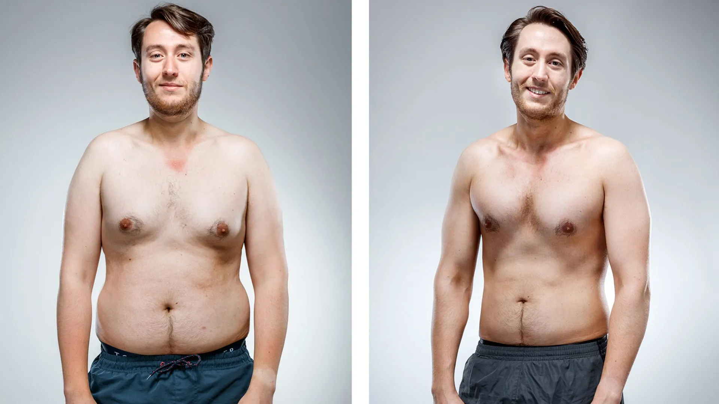

Losing belly fat requires a comprehensive approach that combines science-backed strategies, a healthy diet, and targeted exercises.

Here is an expert guide to help you achieve effective and sustainable results:

**Types of Belly Fat:**

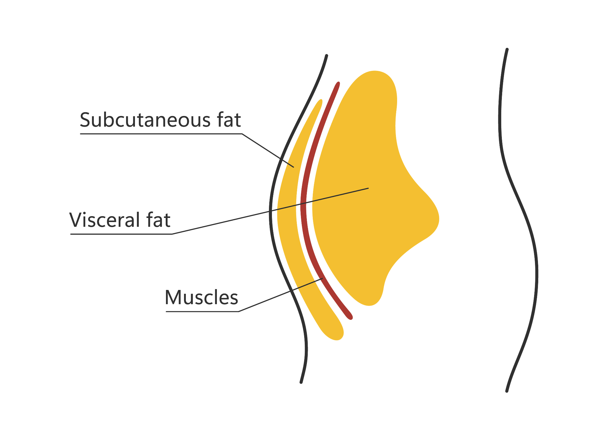

1. Subcutaneous Fat: This fat is found just beneath the skin. While it's visible, it's not as concerning from a health perspective.
2. Visceral Fat: Deeper fat around internal organs. It releases chemicals that can contribute to various diseases. Visceral fathas been linked to insulin resistance, inflammation, and an increased risk of heart disease and type 2 diabetes.

**Science-Based Diet Tips:**

1. **Eat plenty of soluble fiber**

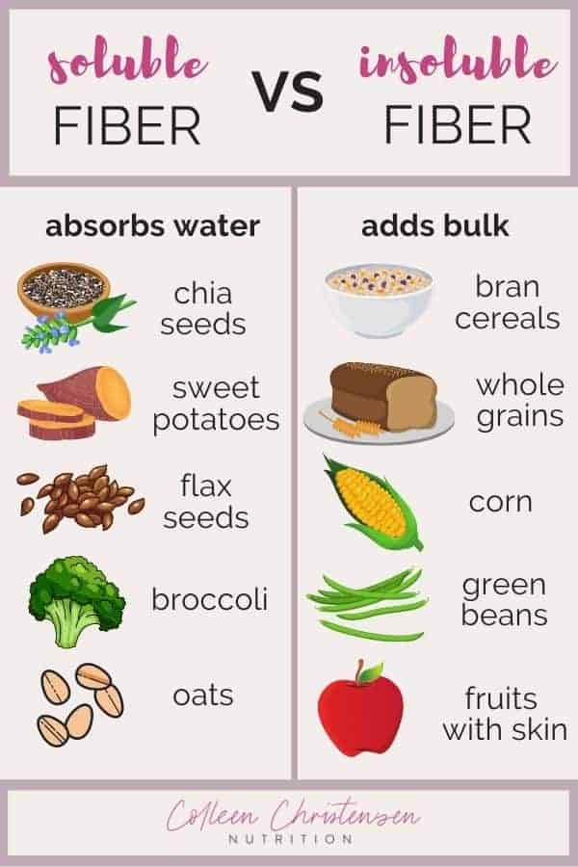

Soluble fiber absorbs water and forms a gel that helps slow

down food as it passes through your digestive system.

Studies show that this fiber may promote weight loss by helping

you feel full, so you naturally eat less.

What’s more, soluble fiber may help reduce belly fat.

Excellent sources of soluble fiber include:

* fruits
* vegetables
* legumes
* Oats
* barley

1. **Avoid foods that contain trans fats**



Trans fats are created by pumping hydrogen into unsaturated

fats, such as soybean oil.

These fats have been linked to inflammation, heart disease,

insulin resistance, and abdominal fat gain in observational and

animal studies.

A 6-year study found that monkeys who ate a high-fat diet

gained 33% more abdominal fat than those eating a diet high in

monounsaturated fat.

To help reduce belly fat, read ingredient labels carefully and stay

away from products that contain trans fats.

These are often listed as partially hydrogenated fats.

1. **Moderate your alcohol intake**



Alcohol can be harmful if you drink too much.

Research suggests that too much alcohol can contribute to belly

fat.

Observational studies link heavy alcohol consumption to a

significantly increased risk of developing excess fat storage

around the waist.

Cutting back on alcohol may help reduce your waist size. You

don’t need to give it up completely, but limiting the amount you

drink in a single day can help.

One study on alcohol use involved more than 2,000 people.

Results showed those who drank alcohol daily but averaged less

than one drink per day had less belly fat than those who drank

less frequently but consumed more alcohol on the days they

drank.

1. **Eat a high protein diet**

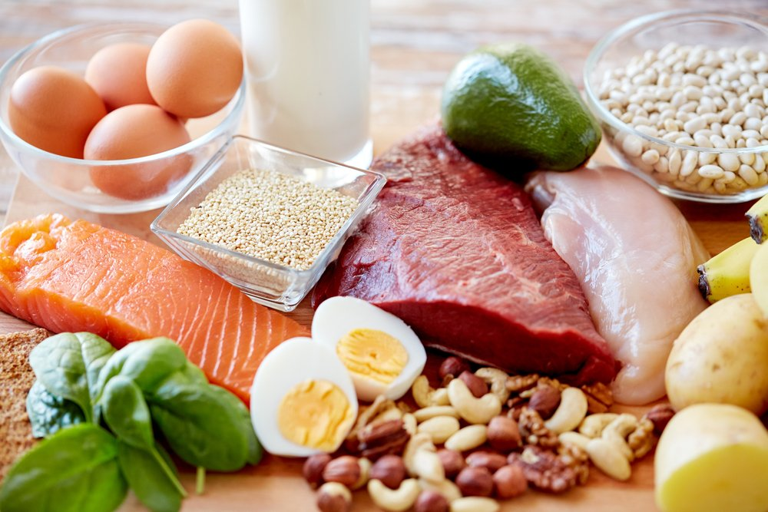

Protein is an extremely important nutrient for weight

Management.

High protein intake increases the release of the fullness

hormone peptide YY, which decreases appetite and promotes

fullness.

Protein also raises your metabolic rate and helps you to retain

muscle mass during weight loss.

Be sure to include a good protein source at every meal, such as:

* meat
* fish
* eggs
* dairy
* whey protein

1. **Stop eating processed sugar foods**

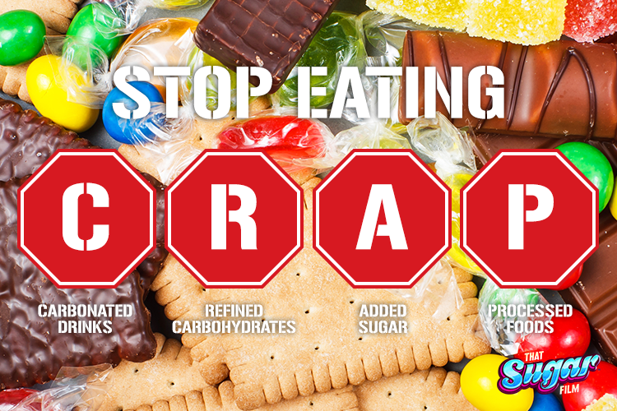

Processed Sugar contains fructose, which is linked to several chronic diseases when consumed in excess.

These include heart disease, type 2 diabetes, and fatty liver disease.

Observational studies show a relationship between high sugar intake and increased abdominal fat.

Limit your intake of candy and processed foods high in added sugar.

1. **Cut back on carbs, especially refined carbs**

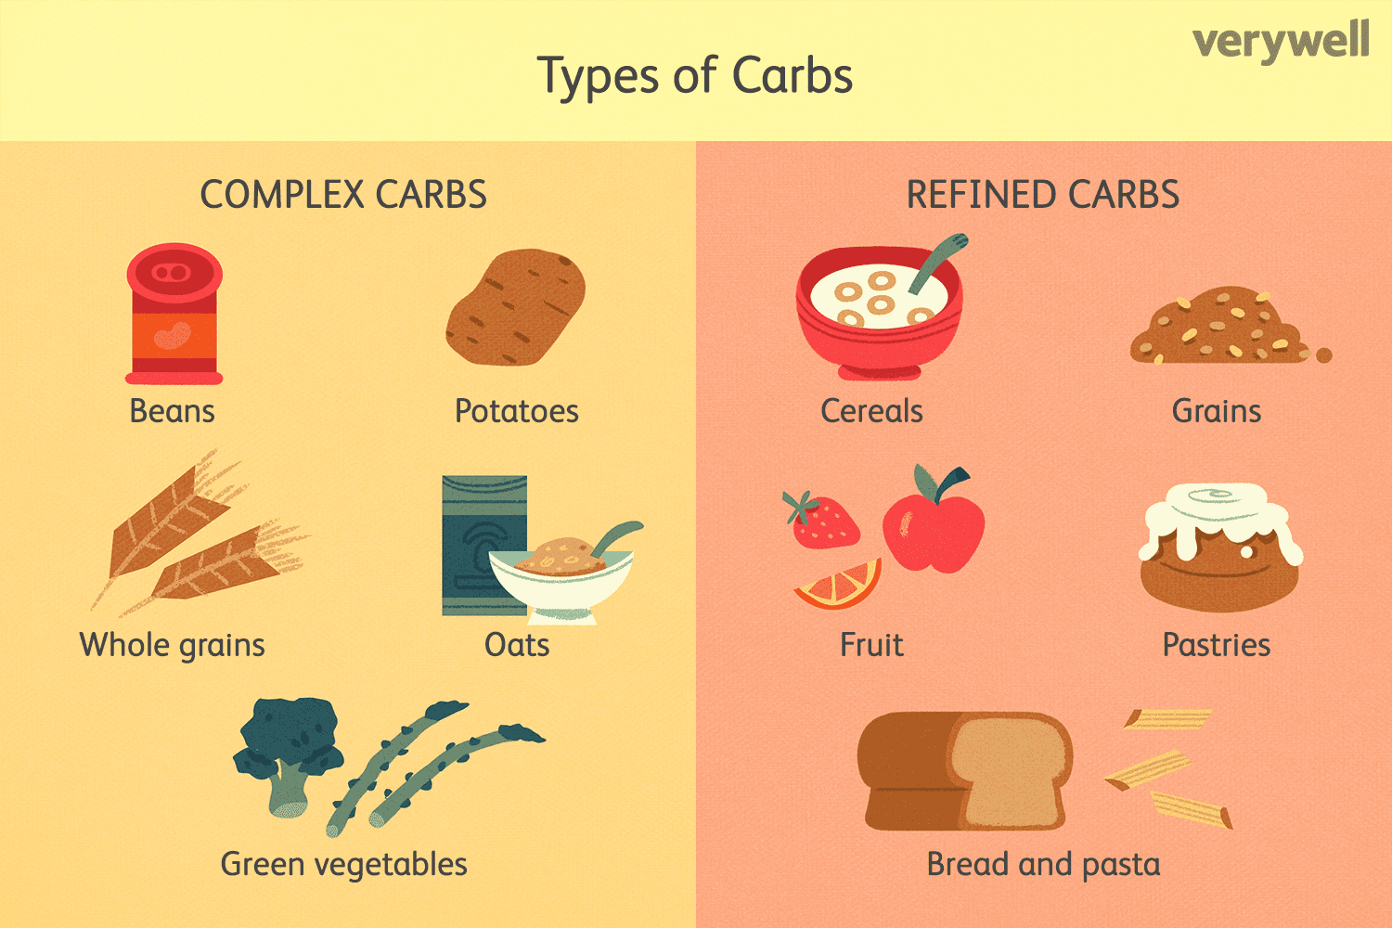

Reducing your carb intake can be very beneficial for losing fat, including abdominal fat.

In fact, low carb diets may cause belly fat loss in people with overweight, those at risk for type 2 diabetes, and people with polycystic ovary syndrome (PCOS).

You don’t have to follow a strict low carb diet.

Some research suggests that replacing refined carbs with unprocessed starchy carbs may improve metabolic health and reduce belly fat.

1. **Do intermittent fasting**

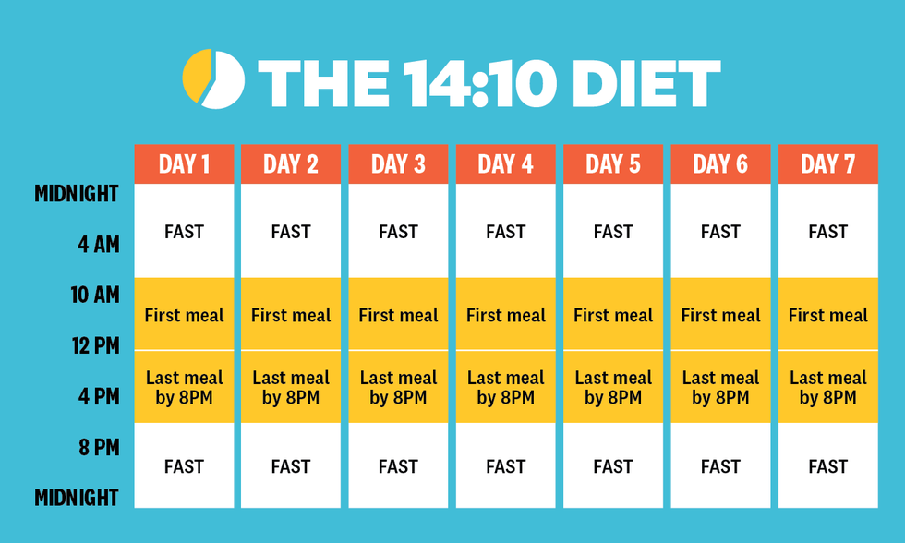

Intermittent fasting has recently become very popular as a

weight-loss method.

It’s an eating pattern that cycles between periods of eating and

periods of fasting.

One popular method involves 24-hour fasts once or twice per

week. Another consists of fasting every day for 16 hours and

eating all your food within an 8-hour period.

One study found that combining intermittent fasting with protein

pacing — which involves consuming nutrient-dense meals

spaced evenly throughout the day — led to greater reductions in

body weight, total fat, and visceral fat compared to calorie

Restriction.

1. **Get plenty of quality sleep**



Sleep is important for many aspects of your health, including weight.

Studies show that not getting enough sleep may be linked to a higher risk of obesity and increased belly fat for some groups.

A 16-year study involving more than 68,000 women found that

those who slept fewer than 5 hours per night were significantly

more likely to gain weight than those who slept 7 hours - 8 hours

per night.

The condition known as sleep apnea, where breathing stops intermittently during the night, has also been linked to excess visceral fat.

In addition to sleeping at least 7 hours per night, make sure you’re getting sufficient quality sleep.

If you suspect you have sleep apnea or another sleep disorder, consider speaking to a doctor about treatment options

**Tailored Workout Plan:**

**1. Cardiovascular Exercise:**



Cardio exercises elevate heart rate, burning calories and promoting overall cardiovascular health.

How to Achieve:

* Plan: Aim for at least 150 minutes of moderate-intensity cardio per week or 75 minutes of vigorous-intensity.
* Activities: Choose activities you enjoy – brisk walking, jogging, cycling, swimming.
* Intensity: Adjust intensity based on fitness level; start slow and gradually increase.

**2. Strength Training:**

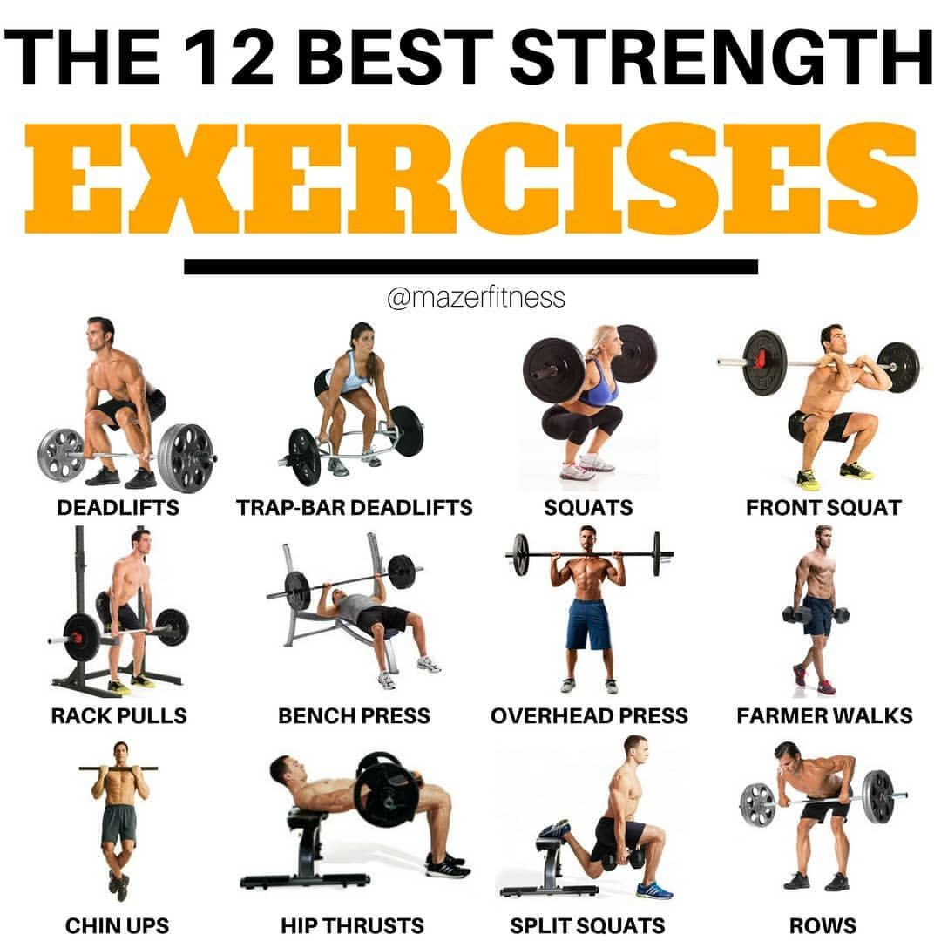

Strength training builds lean muscle mass, which boosts metabolism and contributes to a toned physique.

How to Achieve:

* Plan: Include 2-3 sessions per week targeting major muscle groups – legs, chest, back, arms, and core.
* Exercises: Squats, deadlifts, bench press, rows, bicep curls, tricep dips.
* Sets and Reps: Start with 3 sets of 10-15 reps for each exercise, gradually increasing weight.

**3. Core Exercises:**

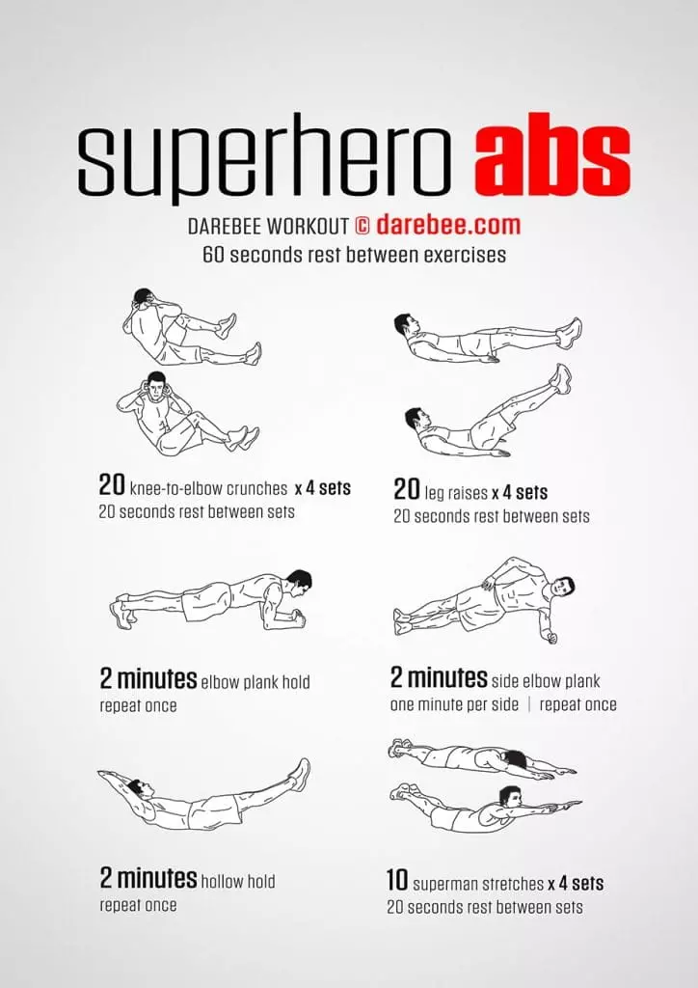

Core exercises strengthen abdominal muscles, improving posture and creating a flatter stomach.

How to Achieve:

* Plan: Incorporate core exercises 2-3 times per week, allowing for recovery.
* Exercises: Planks, Russian twists, leg raises, bicycle crunches, mountain climbers.
* Sets and Reps: Begin with 2-3 sets of 12-15 reps for each exercise, adjusting as needed.

**4. HIIT Workouts:**

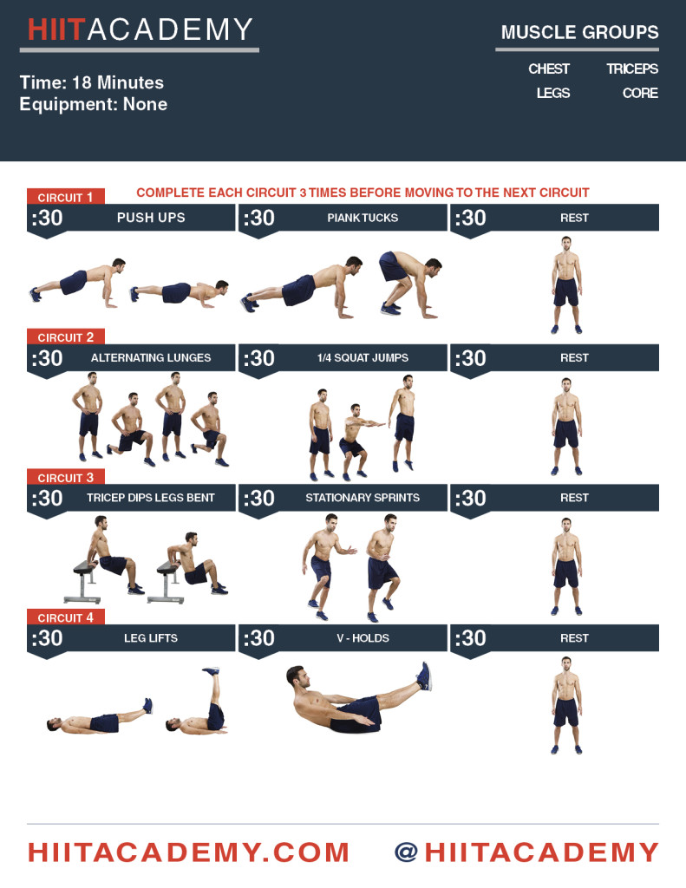

High-Intensity Interval Training (HIIT) maximizes calorie burn during and after workouts.

How to Achieve:

* Plan: Include 1-2 HIIT sessions per week, allowing for recovery.
* Exercises: Jump squats, burpees, high knees, mountain climbers, sprinting.
* Timing: 20-30 seconds of intense effort followed by 10-15 seconds of rest, repeat for 15-30 minutes.

**General Tips:**

1. Gradually increase intensity, duration, or resistance as fitness improves.

2. Include 5-10 minutes of light cardio and dynamic stretches before and static stretches after each session.

3. Allow 48 hours between strength training sessions for muscle recovery.

**Conclusion:**

Removing belly fat is a multifaceted process that involves understanding the science, implementing dietary changes, engaging in targeted exercises, and adopting a healthy lifestyle.

It's essential to approach this journey with patience, consistency, and a willingness to make sustainable changes.

Remember, the key to success is a holistic and personalized approach.

--------------------------------

Thank you for reading,

I hope you find this guide helpful.

**P.S. I have a newsletter called** [**“1-2-3 Health”**](https://1-2-3health.beehiiv.com/subscribe) **where I share 1 quote, 2 industry news and 3 FREE resources every Sunday.**

You’re automatically subscribed to that after buying this guide.

I hope my newsletter helps you in your journey of achieving true health.

See you every Sunday,

Armaan.

**P.P.S. If you have any questions, DM me on** [**X (Twitter).**](https://twitter.com/GymBodyFitness_)